.NET Vision
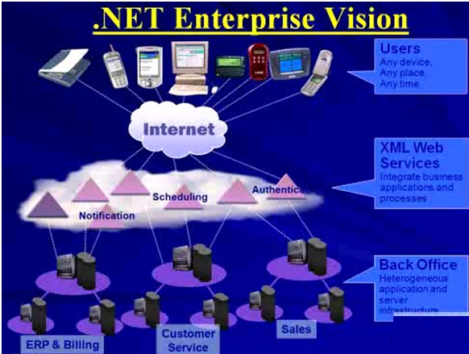

Category of programmers
System Programmers
- One who programs directly for a given hardware.
- e.g. Device Drivers or extremely low level o/p services.
Application Programmers
- One who programs application used by people for their requirements.
- e.g. Calculator, Calendar, MS-Office Packages, Account Packages etc…
Note: .NET is for Application programming and not for System programming.

Definitions:
Platform:
- It is an environment for developing and executing application.
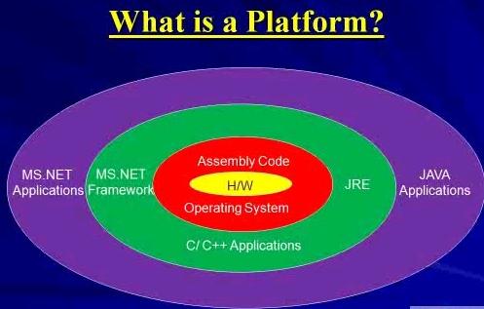

Framework
- It is ready to use collection of classes and interfaces used for developing a particular type of application.
- MS.NET is a framework built on open internet protocols and standards with tools and services that meld computing and communication in new ways.
- It’s an environment for developing and running software applications featuring ease of development of web based services, rich standard runtime services available to components written in variety of programming languages and provides inter languages and inter machine inoperability.
Framework Components
MS.NET Framework Runtime
- Used for both development and production of .NET applications.

MS.NET Framework SDK
- Mostly used only for development of .NET applications.
Visual Studio .NET
- IDE and RAD tool for developing .NET applications.
- Not needed on production machine.
- Common environment for multiple languages like VB.NET, C#, VC++.
- Can be used any type of MS.NET application.
- Can be used also for non .net based applications like PHP pages. For this we need a plug-in to be installed over studio.
MS.NET Framework Versions
- Version 1.0 in year 2002
- Version 1.1 in year 2003
- Version 2.0 in year 2005--- base
- Version 3.0 in year 2006
- Version 3.5 in year 2008
- Version 4.0 in year 2010--- base
- Version 4.5 in year 2012
- Version 4.8 in year 2019 (.NET 5)
- Note: All versions can be installed side by side on same machine.
Version Dependency
- 1.0 is a standalone version
- 1.1 is a standalone version
- 2.0 is a standalone as base version
- 3.0 is installed over 2.0
- 3.5 is installed over 3.0
- Note: So the machine having 3.5 will also have version 2.0 and 3.0 installed on it but 1.0 and 1.1 needs not will be installed.
Version Compatibility
- Doesn’t support Forward or Backward compatibility.
- The version used on development machine and production machine must be same.
- Note: If 1.1 has been used for development and on the production machine even if 2.0 is installed and if 1.1 is not then the application will not work.
The core of .NET Framework
- Application Services
- Framework/Base Class Library
  - Provides the core functionality: ASP.NET, Web-Services, ADO.NET, Windows Forms, IO, XML, etc.
- Common Language Runtime
  - Garbage collection
  - Language integration
  - Multiple versioning support (no more DLL hell!)
  - Integrated security
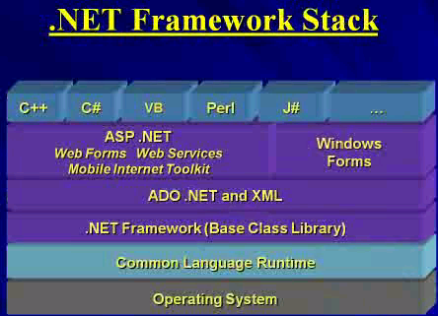
Types of MS.NET Application
- Console Based Application (e.g. Compiler)
- Window Application (WinForms)
- Windows Services
- ASP.NET Web Applications
- ASP.NET Web Services
- Remoting Application
- Mobile/Smart Device Applications

Benefits of .NET Framework
- Ease of Use
  - Object-oriented model
  - Namespace and Framework structure
  - .NET Framework offer functionality, ease of use, and production capabilities not available today.
  - In .NET Framework everything is an object, and that coupled with the layout of the namespaces, the .NET Framework is easier to use than the existing, competing frameworks or class libraries. Ease of use increases productivity.
- Freedom to choose
  - The language that meets your needs
  - The development tool that will make it easier to learn programming
  - Certainly, the ability to choose any of the several existing popular languages currently available to the .NET platform makes developing .NET-based solutions more practical, cost efficient, and, dare we say, pleasant! You can choose the language that meets your needs and the tool you know best. Currently, most development languages are tied to a tool and class libraries are tied to the target platform, perhaps to the tool, and certainly to the language. The common type system and common language runtime empower .NET to break this restrictive chain.

- Stability
  - Garbage collection
  - Common language runtime’s garbage collector manages memory. How does this improve stability? By automating memory management, it eliminates one of the most common sources of system failures (and of development headaches)—the memory leak. The garbage collector also dramatically simplifies the development process by relieving the developer from the need to manually track memory use.
  - Assemblies eliminates DLL compatibility issues
  - Not only can you wave “goodbye” to the memory leak, but to DLL compatibility issues as well!
  - In .NET, solutions are packaged and delivered in an assembly. In a nutshell, assemblies are a box into which the software vendor dumps all his components. It is a self-contained, self-documented deployment model that is restricted from interfering with other programs or assemblies. While one assembly can use components or services of another, it cannot replace anything that is not in its own box.
  - Additionally, because the Framework exposes system functionality through its System namespaces and enables you to derive your own specialized version from any other namespace, overwriting operating system–critical libraries is impossible!

- Security
  - Restricting or containing the illegal memory reference
  - Comprehensive security model

- Deployment and Management
  - Solutions are assembled and run securely using the assembly and the common language runtime.
  - The assembly also makes version maintenance easier for both the development organization and corporate customer: .NET permits “side-by-side” deployment of versions, and versions are self-contained, making updates, service fixes, and upgrades more manageable.
- Unified Experience
  - .NET is designed using open standards to facilitate integration of disparate .NET solutions and provides functionality to integrate non-.NET technology and solutions such as COM/COM+. There is one single .NET Framework and the same classes used to build the .NET platform are also available to you!
- Web Services
  - Web Services provide both a means to produce and consume disparate service solutions and do so using different pricing models.

Compilation and execution of .NET Application

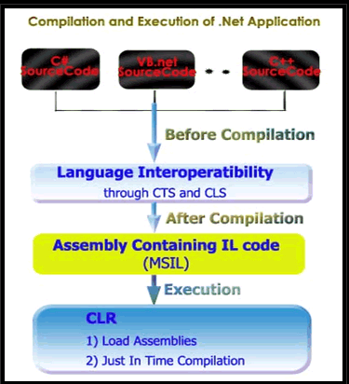

Example 1:

ConsoleApplication.cs

using System;
class ConsoleApplication
{
static void Main()
{
Console.WriteLine("Hello C#");
for(int i=1;i<5;i++)
{
for(int j=1;j<=i;j++)
{
Console.Write("*");
}
Console.WriteLine();
}
string name=Console.ReadLine();
Console.WriteLine("Hello"+" "+name);
Console.WriteLine("Enter Number1:");
int num1=int.Parse(Console.ReadLine());
Console.WriteLine("Enter Number2:");
int num2=int.Parse(Console.ReadLine());
int ans=num1+num2;
Console.WriteLine("Addition is: "+a ns);
}
}

Set the Path:
Right Click on My Computer -> Properties -> Advance -> Environmental variable
Click on New
Variable name Path
Variable value .;C:\Windows\Microsoft.NET\Framework\v2.0.50727
Click OK
Compile
D:\> csc ConsoleApplication.cs
Execute
D:\>ConsoleApplication.exe

Objectives

- Vision -> Develop application program, web application
- Platform - environment for developing and executing application.
- .NET -> Platform Independent or dependent??
- Framework
- Namespace
- MS.NET Framework runtime use for both development and production of application. (T/F)
- MS.NET Framework SDK use for both development and production of application. (T/F)
- Why we use visual studio to develop .net application?
- How many versions available of .NET framework?
- Which .net framework version called based version? Why?
- Application develop in framework 1.0, execute on framework 3.0 successfully. (T/F)
- Application develops in framework 3.0 without using any extra feature available in 3.0. Will it work in framework 2.0 on targeted machine? Why?
- CLR provide bridge (layer) between .NET framework and Operating System. How?
- Which elements of .NET framework provide language inter-operatibility (multiple language support)?
- Which part of .NET framework refers as “executable engine”?
- JIT is use to represent data (data type) in memory. (T/F)
- Is MSIL CPU specific?
- How MSIL converted into native code?
- .NET framework understand
a) C# b) C# and VB
c) MSIL d) CLS

